Nama : Andrew Nicholas  
NIM : 2602100171

HOME PAGE

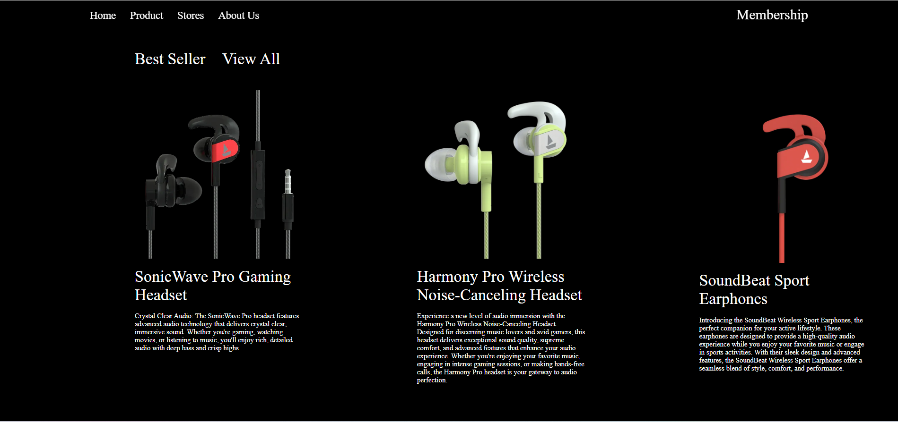

In this home page, the main point is to introduce our website and company to our user. The thing I show is a logo with our company name and also company’s slogan. We keep the website aesthetic by overlaying our logo with a playing video in the background. Secondly, we want to show our expertise in selling gaming gear, shown by the second picture we straight up show our best seller product. At our Gaming Store, we are dedicated to bringing you the ultimate gaming experience. As gaming enthusiasts ourselves, we understand your passion for immersive gameplay, cutting-edge technology, and the latest gaming gear. Whether you're a casual gamer or a hardcore enthusiast, we have everything you need to take your gaming to the next level.

PRODUCT PAGE

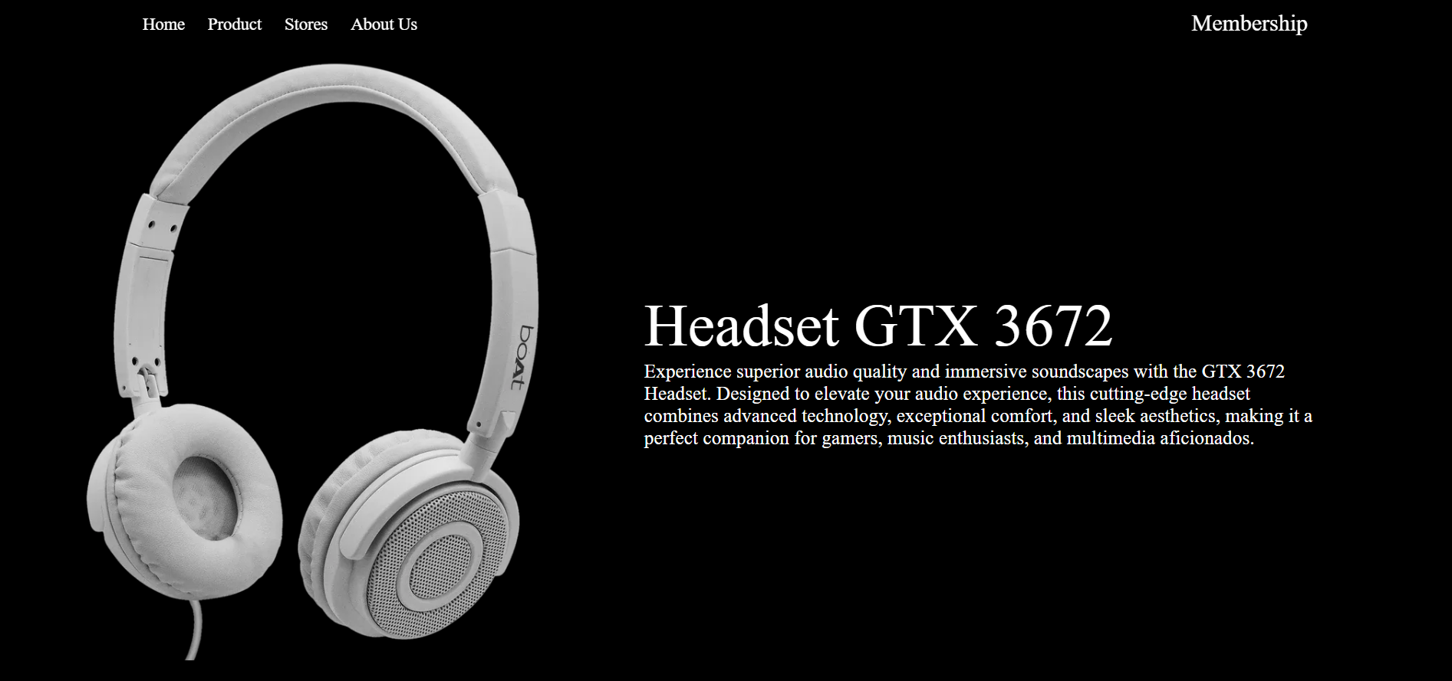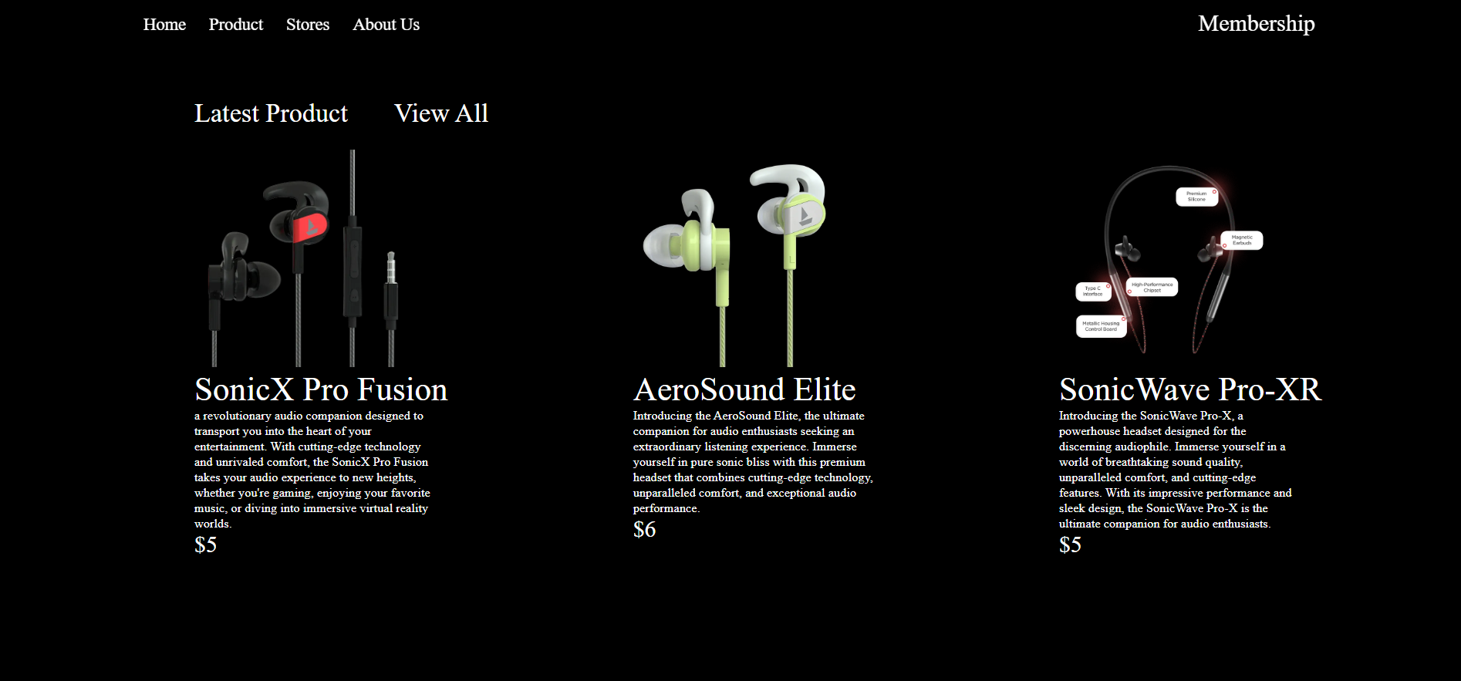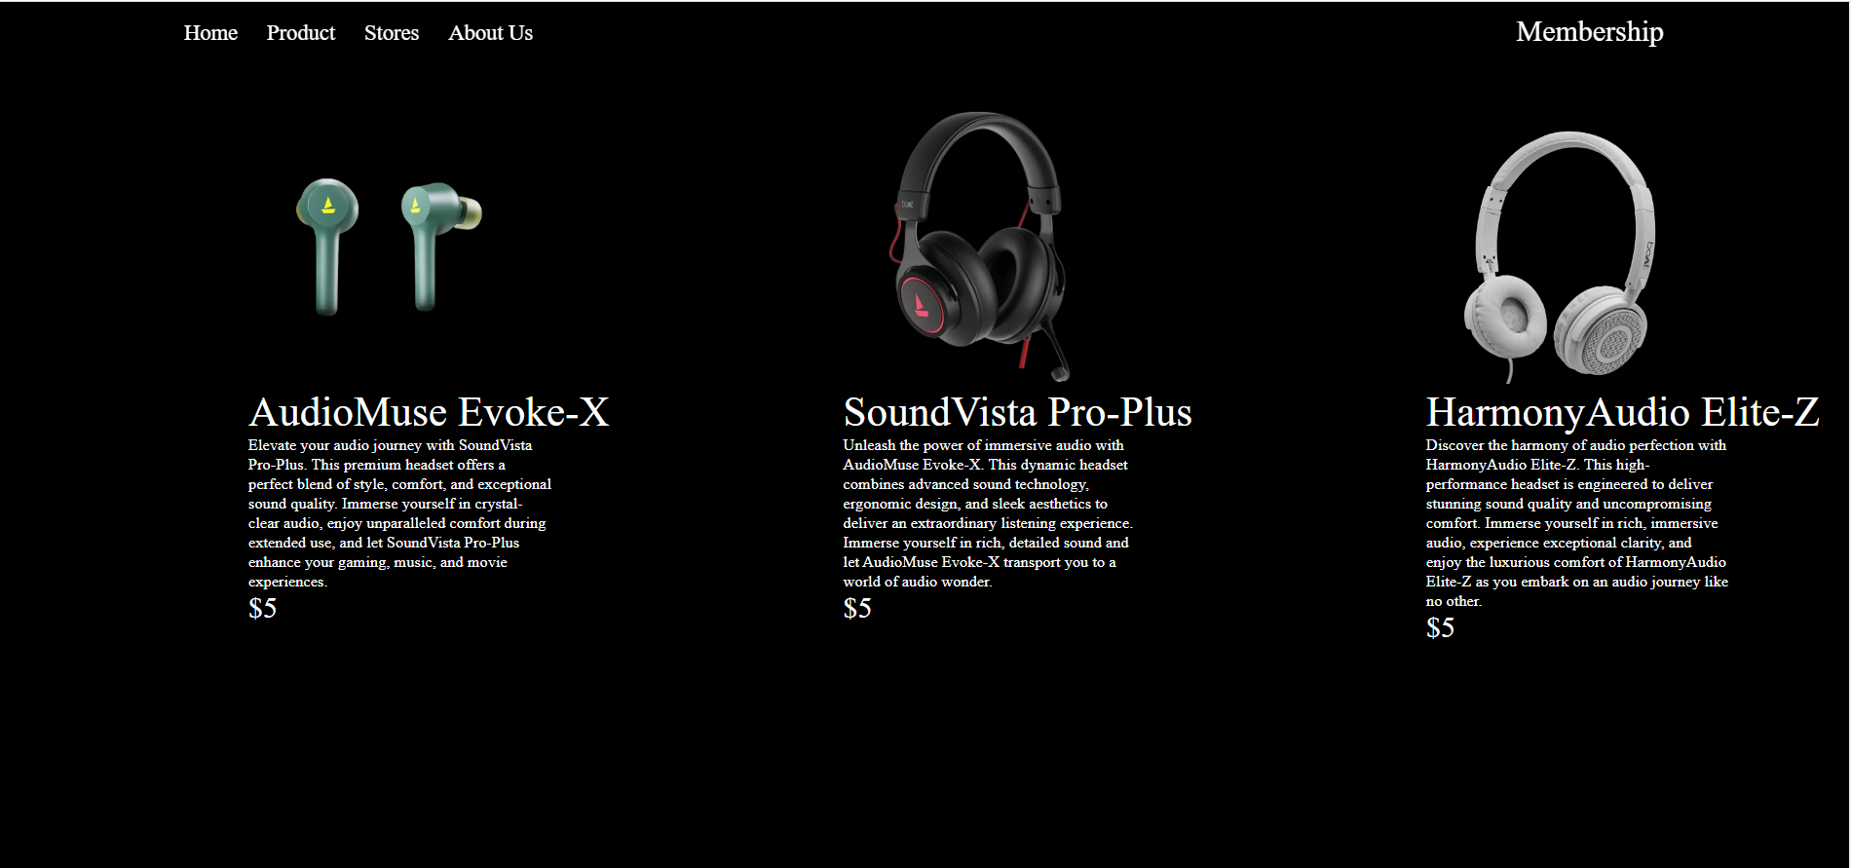

In Our Product Page, we focus on showing our user the items that we are selling. We display our brand new release at the very top, followed by list of our products. We display product name, description, and price. Here you'll find a comprehensive selection of the finest gaming products available. We take pride in curating a wide range of top-quality gaming gear to cater to all types of gamers. Whether you're a casual player or a professional eSports enthusiast, we have the perfect products to enhance your gaming experience.

MEMBERSHIP PAGE

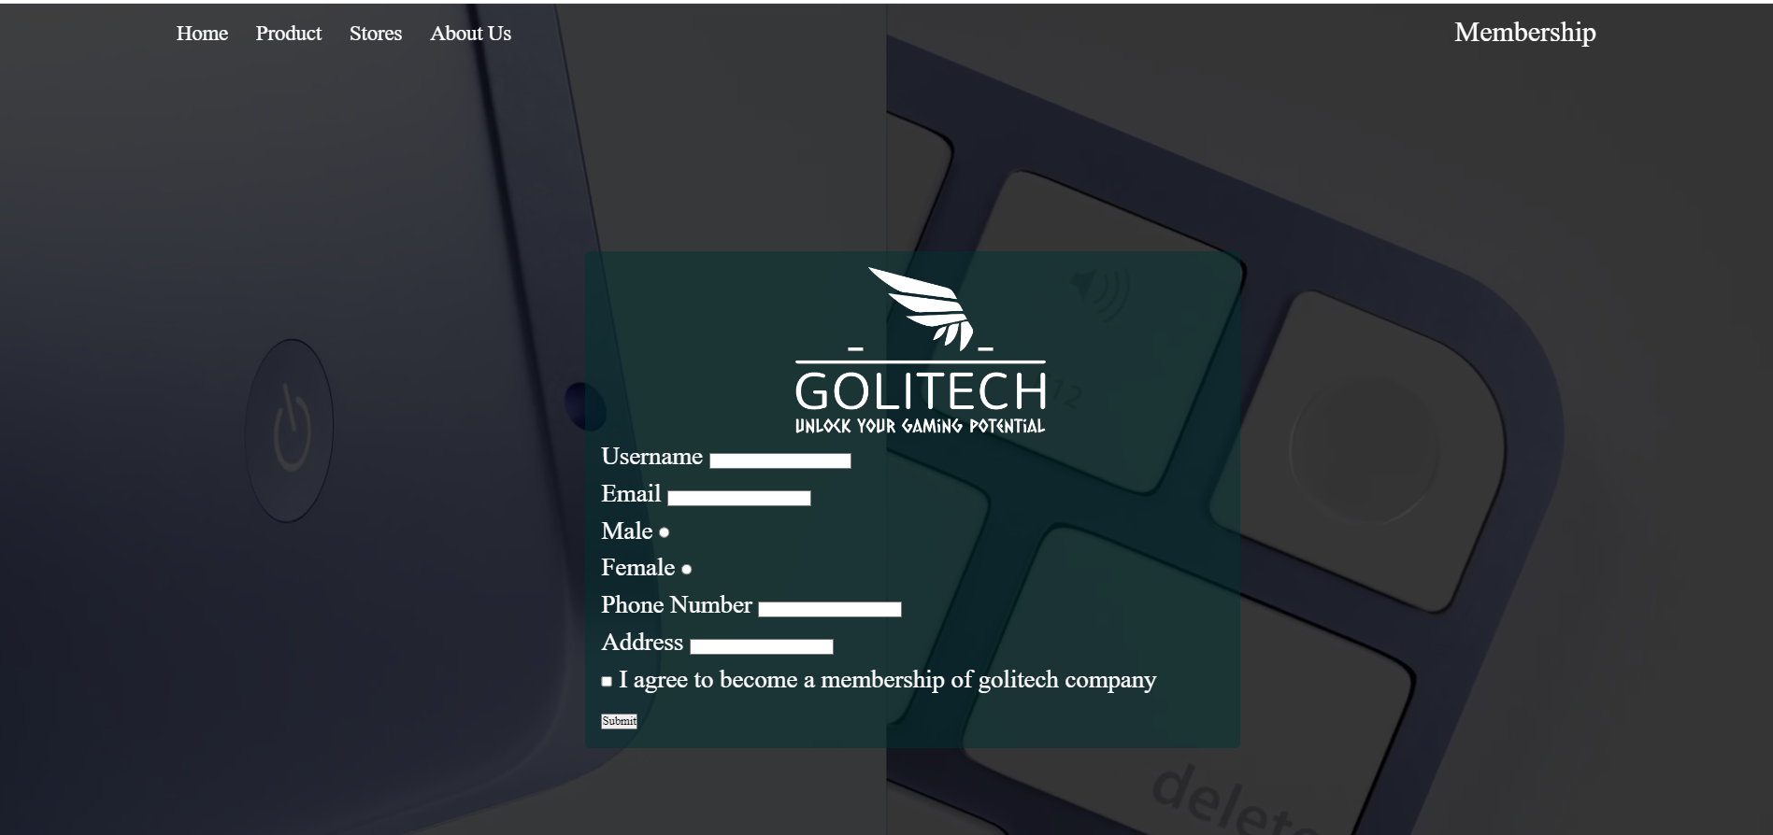

In this page, our goal is to serve a membership role to our customer. We ask for user’s username, email, gender, phone number, and address for this form. The form is wrapped with form validation created using javascript. After filling this membership page, our customer will be redirected to our home page.

OUR STORE PAGE

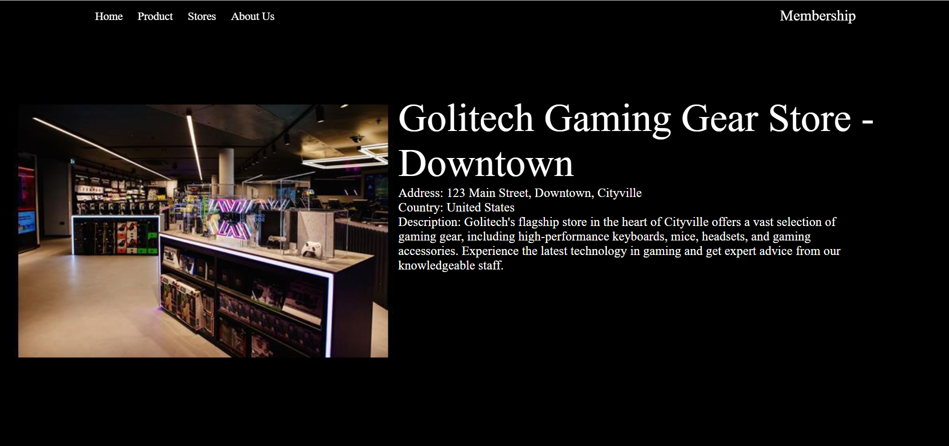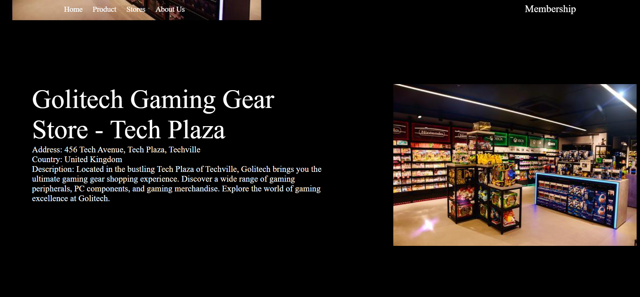

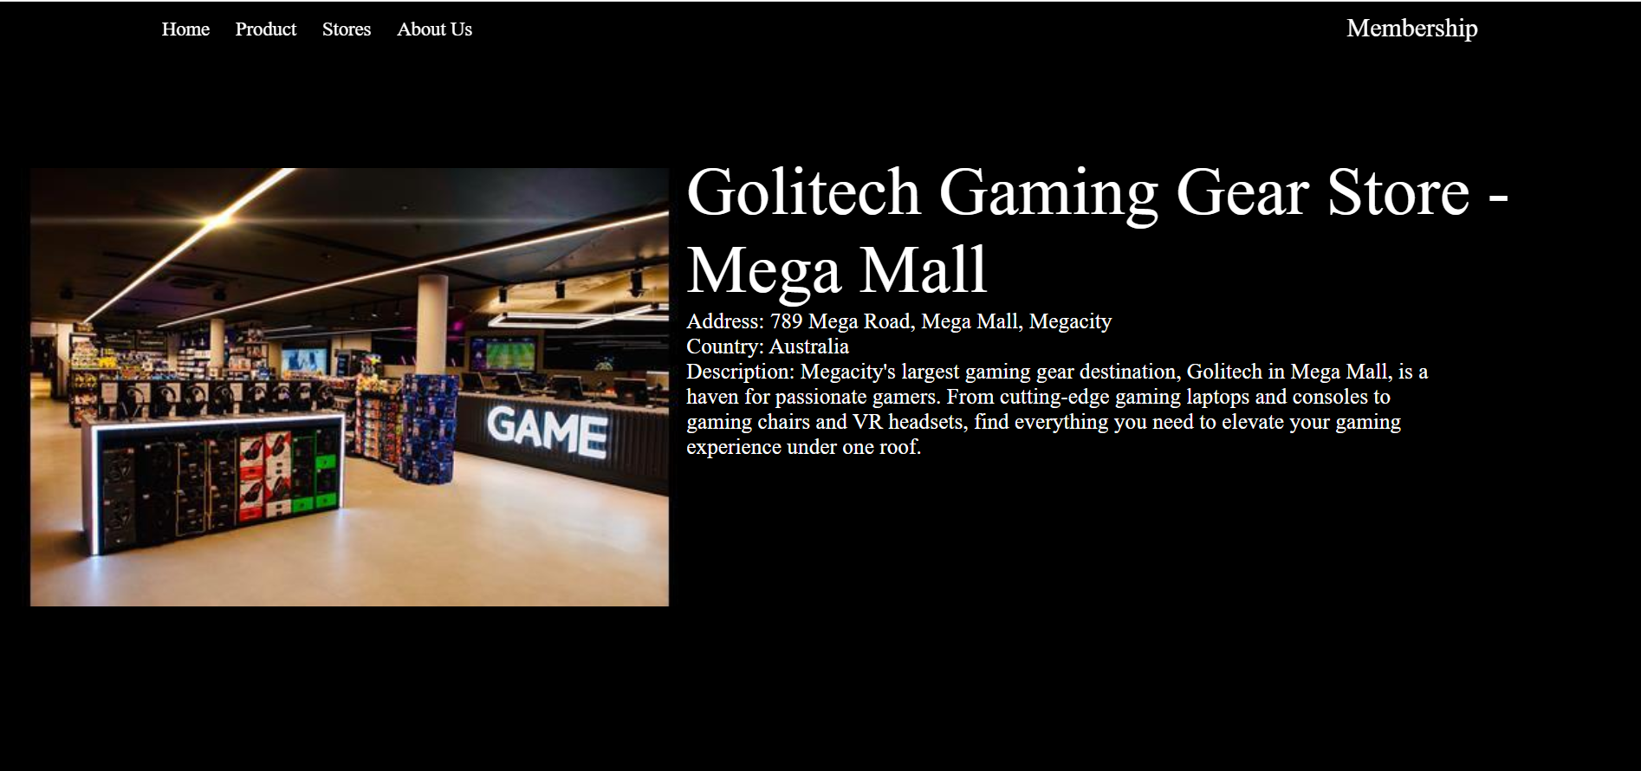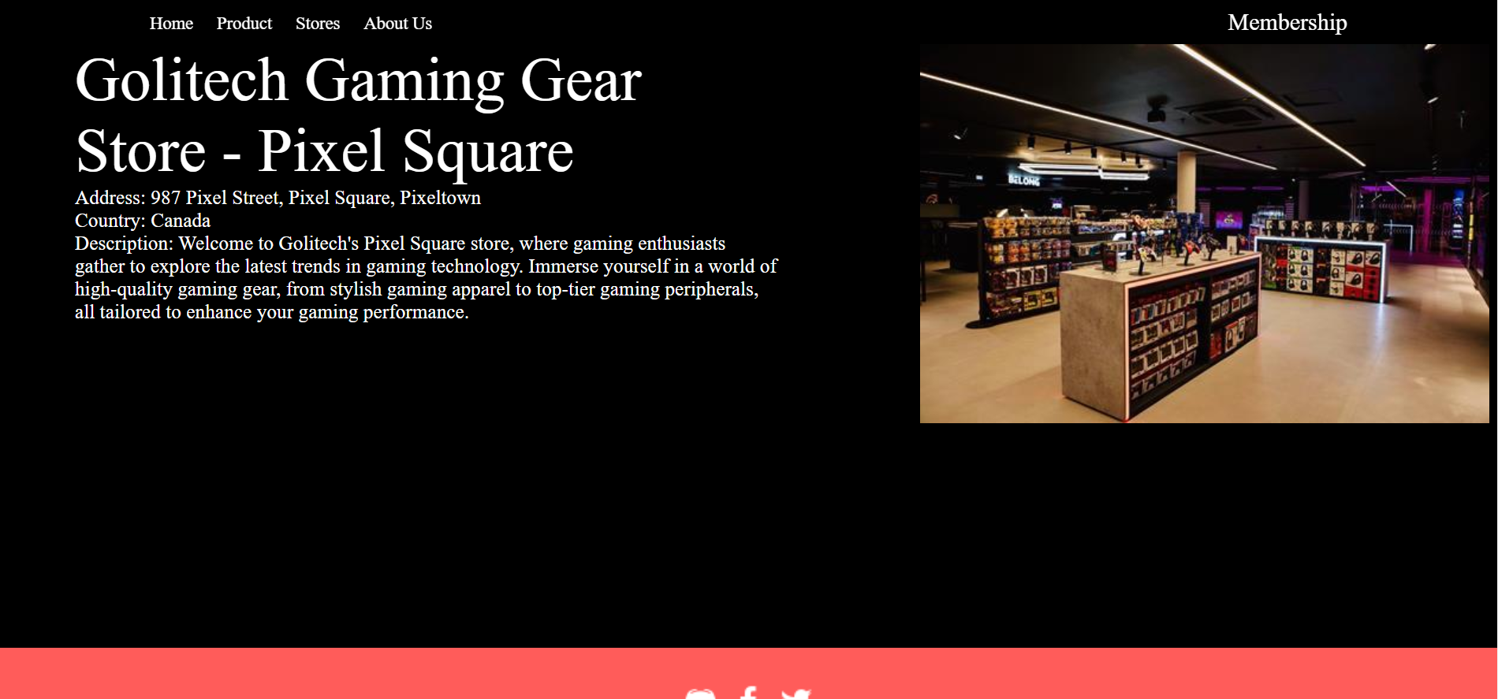

In this page, it’s our stores page. We display all of our offline store here and we provide picture, address or location, and country. We currently have 4 stores offline so we display all 4 of them in this page. So, the goal of this page is to show our customer all of our offline stores. At GoLitech, we believe in providing a personalized shopping experience for our customers. Our offline stores are strategically located in various regions to bring our exceptional gaming products closer to you. On this page, you'll find a comprehensive list of all our store locations, along with key information about each store.

ABOUT US PAGE

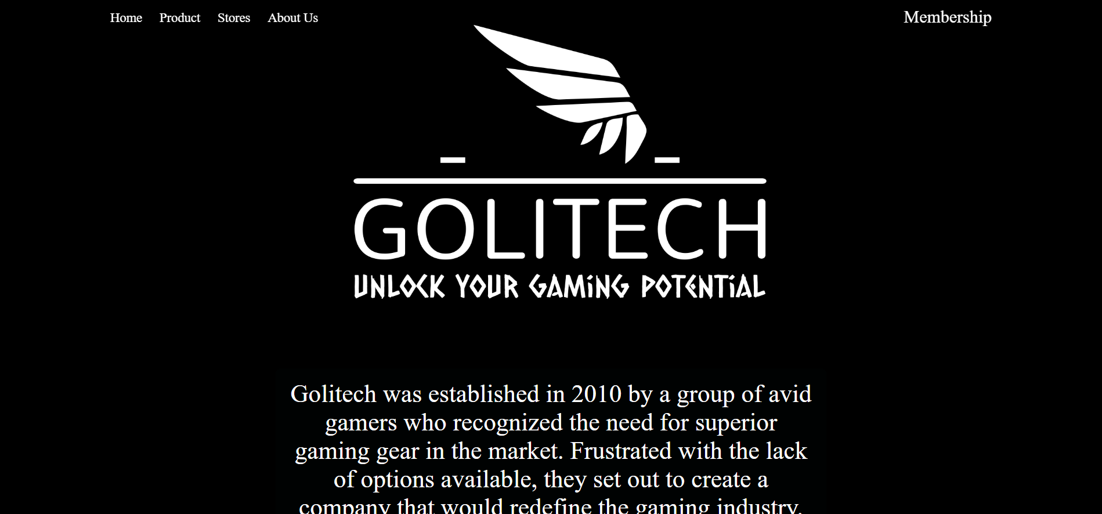

In this page, we provide information about our website. Starting from our history, background, and stories. So this page’s goal is mainly to inform people to know more about our company. At GoLitech, we are passionate about gaming and dedicated to providing exceptional gaming experiences to our valued customers. On this page, we would like to take a moment to share our story and the rich history behind our brand.

RESOURCE

<https://www.retail-week.com/department-stores/in-pictures-game-opens-biggest-belong-arena-in-house-of-fraser/7033761.article>

<https://youtu.be/p1y3lKAC1O8>

JETE KNIGHT BY TINTIN WINATA